Are you concerned about a child?
If you are concerned about a child:
Make a factual record of your concern (include day, date, time, other witnesses, concern and your own signature)
You must share your concerns without delay.
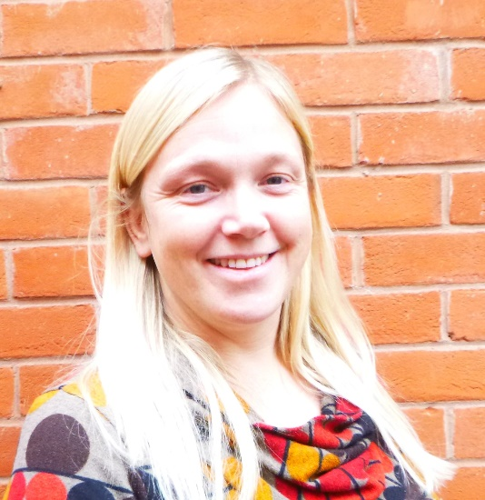
Name of Designated Safeguarding Lead: Nicola Jones

Name of Deputy Safeguarding Lead:
Jack Banister

